**Day-1(2021-07-17)**

Today is the first day of my 1 Hour programming challenge. It took me almost 2 days to decide on which programming language I should focus on. After thinking for 2 days I get to the conclusion that I should focus on js for the first few weeks and after that I should start nodejs. As I have been always admiring mobile applications rather than the website I decided to work on nodejs but jumping directly on nodejs is a bit challenging so for my comfort I started doing js for the first few weeks. Due to not doing programming or coding for the past few months, it was so tough to concentrate and learn programming on my first day. On my first day, the main thing I learn is the difference between HTML, CSS, and JS. The most important thing for a beautiful website is js. Today I did basic js code. JS code is written on <script> tag above the body or below body but the above body is preferred. We can also write js on the web browser. Before coding on idle I code js on browser in the official website of Google. I learn about an alert tag. The alert tag gives an alert message on the website. The class name can be the same but the id should be different for every tag.

**(2021-08-04)**

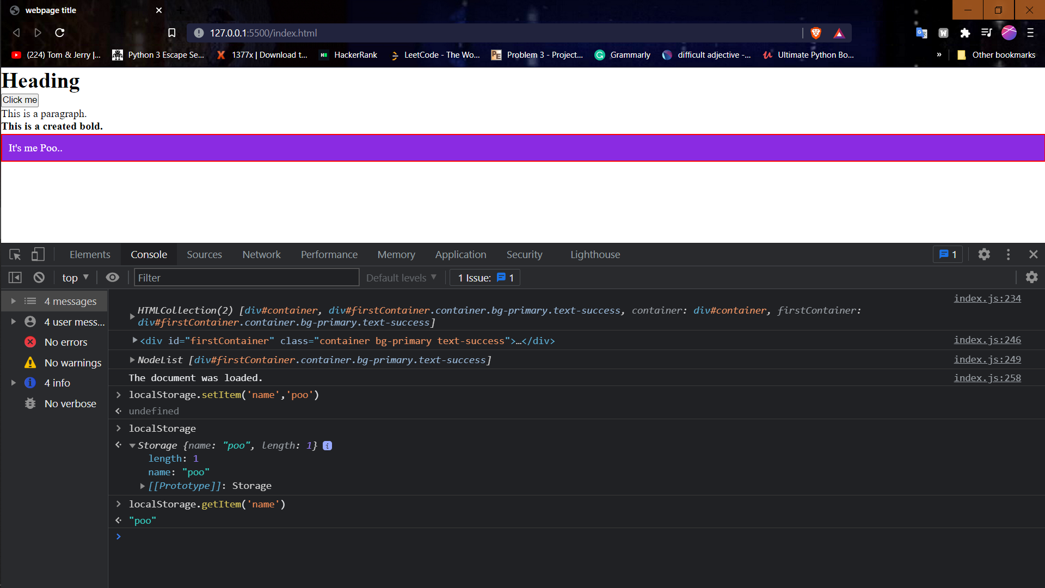

* JSON (JavaScript Object Notation) requires double quotes but js object accept single quotes also.